DAB e.V.
Weidenbachring 14
82362 Weilheim-Marnbach
Tel: +49 881 92451395
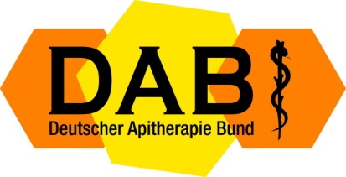

Registration for bee sting therapy training
󠆳 Monday, September 16 to Wednesday, September 18, 2024
󠆳 Friday, September 20 to Sunday, September 22, 2024
Location: Apitherapy Center Oderding, Riedanger 1, 82398 Polling-Oderding
Directions

Surname and first name: ......................................................
Date of birth: ..........................................................................
Street: ........................................................................
Zip code and city: .................................................................
E-mail, telephone, website: ...............................................
Profession: ..........................................................................

Registration (prepayment)
Deposit up to six weeks before the start of the course: EUR 250
for DAB members: 890 EUR
for non-members: 950 EUR

Overnight accommodation is available in nearby restaurants and guesthouses.

I transfer the money: ...... EUR (please specify!!!)
Bank details DAB:
Sparda-Bank Munich
BANK CODE: 700 905 00
Account no: 3297780
IBAN: DE20700905000003297780
BIC (Swift code): GENODEF 1 S 04

Important: Due to the space available, only a limited number of seminar places are available. Participation will therefore be considered according to the time of receipt of registration and payment.

I confirm with my signature the seminar contract conditions!

Date: Signature:

Please fill in legibly and send by e-mail to arno.bruder@tonline.de or verwaltung@apitherapie.de

